21MIS1001 30-07-2024

Sabbarish S Tuesday

SWE-4001

System Programming

----------------------------------------------------------------------------------------------------------------------------------------------------

LAB-1

Working on Files and creation of Symbol table

----------------------------------------------------------------------------------------------------------------------------------------------------

Open and Close a File:

• Write a program to open a file named "test.txt" in read mode. Check if the file is successfully opened. If it is, close the file.

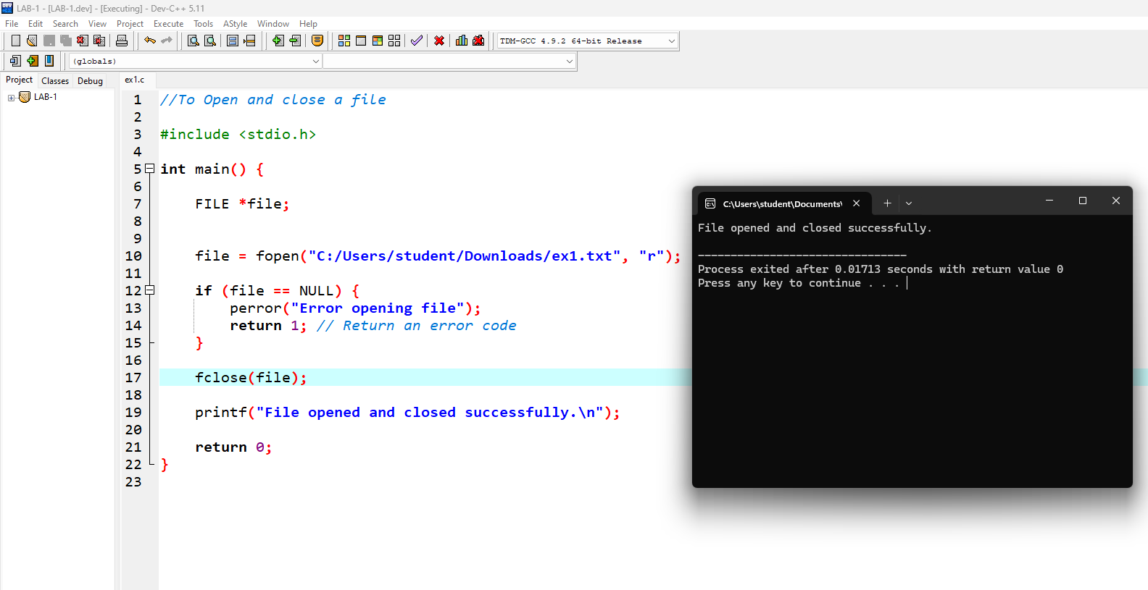

Write to a File:

• Write a program that opens a file named "output.txt" in write mode. Write the string "Hello, World!" to the file. Close the file after writing.

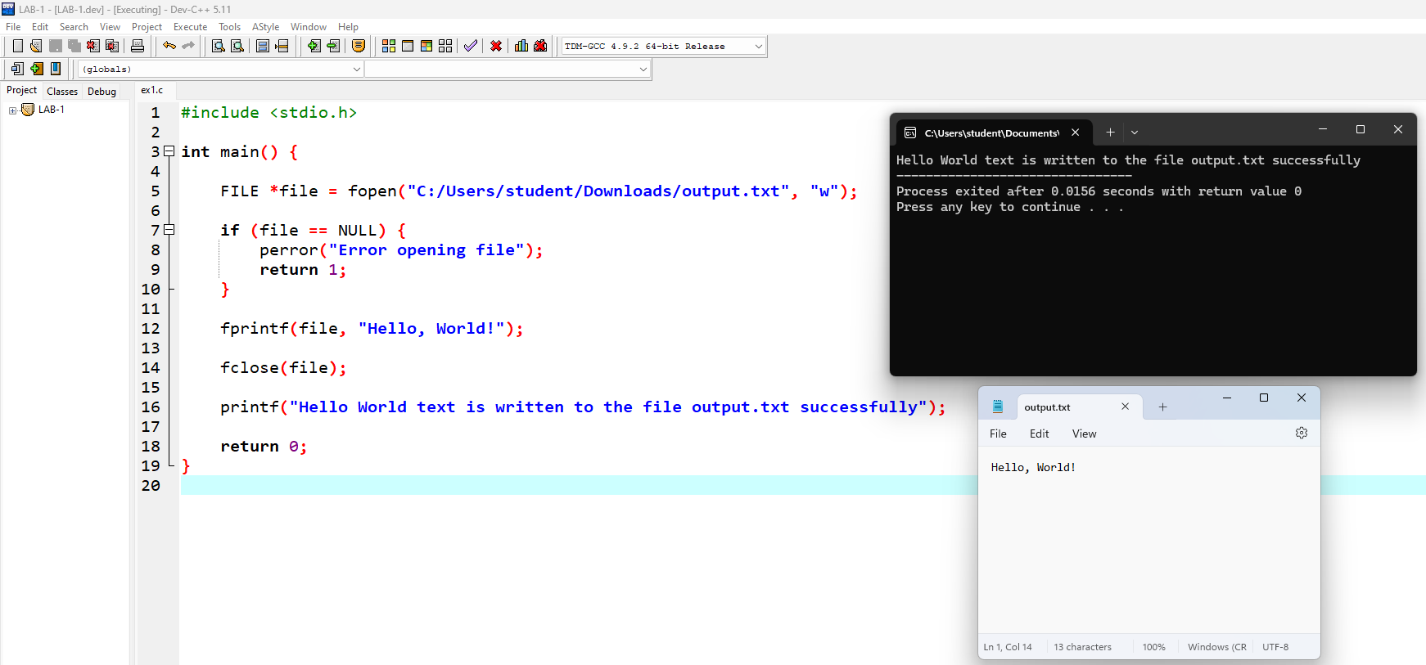

Read from a File:

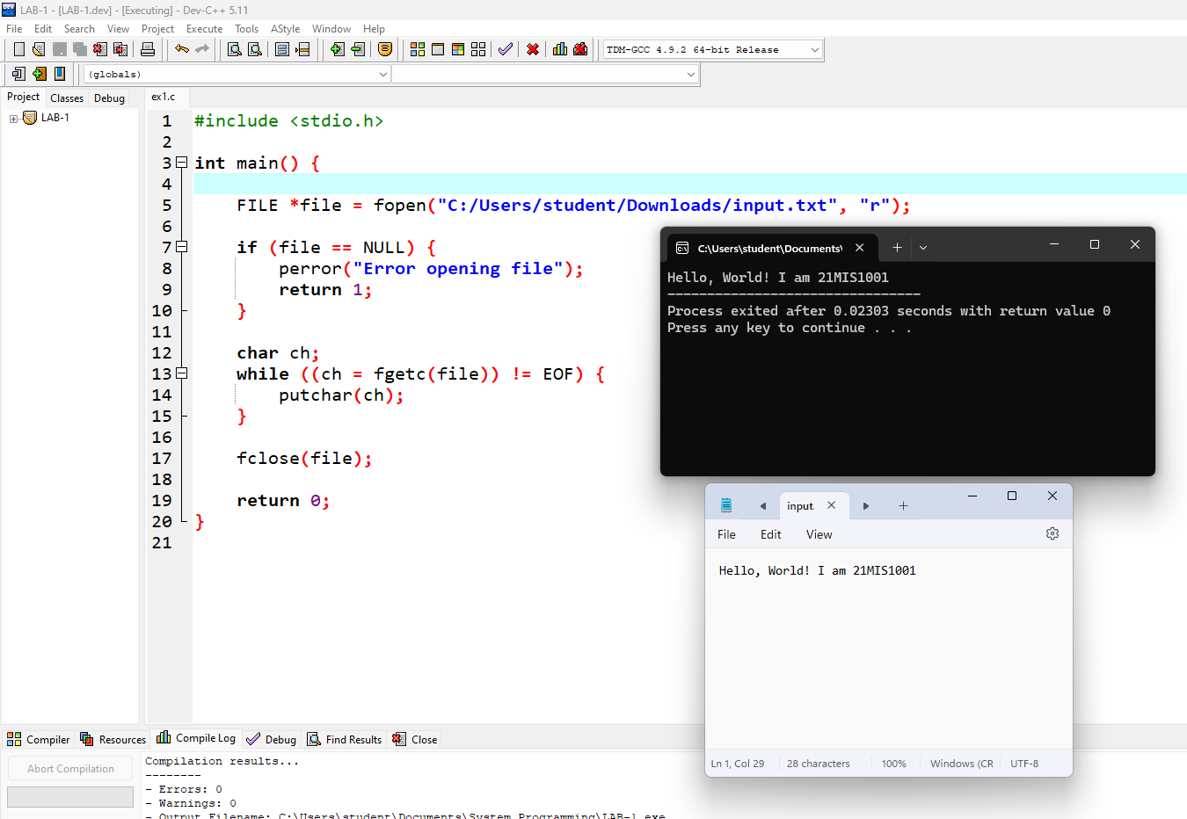• Write a program to read the contents of a file named "input.txt" and print the contents to the console.

Append to a File:

• Write a program that opens a file named "log.txt" in append mode. Append the current date and time to the file. Close the file after appending.

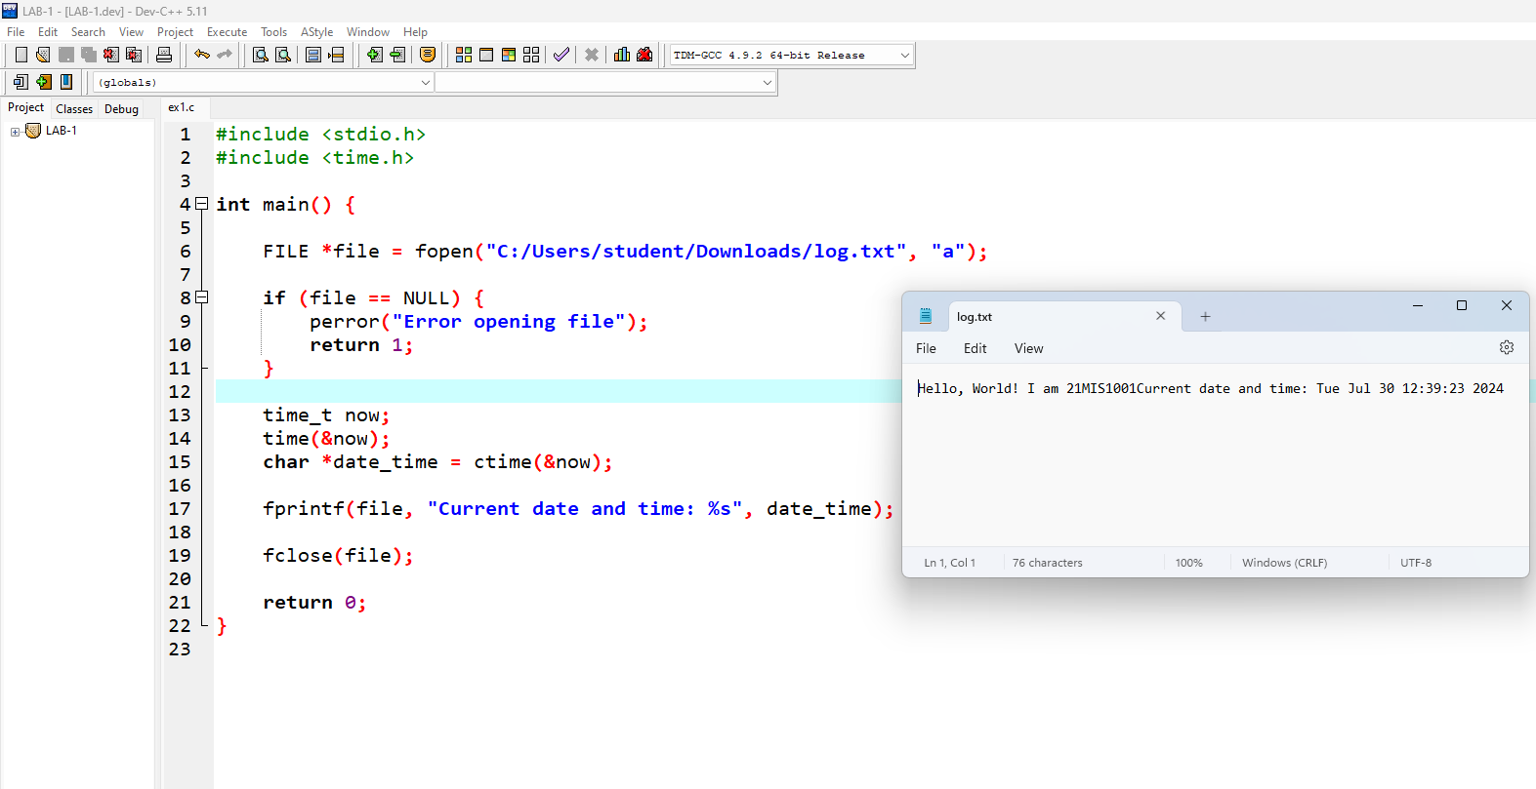

Copy a File:

• Write a program to copy the contents of a file named "source.txt" to a new file named "destination.txt".

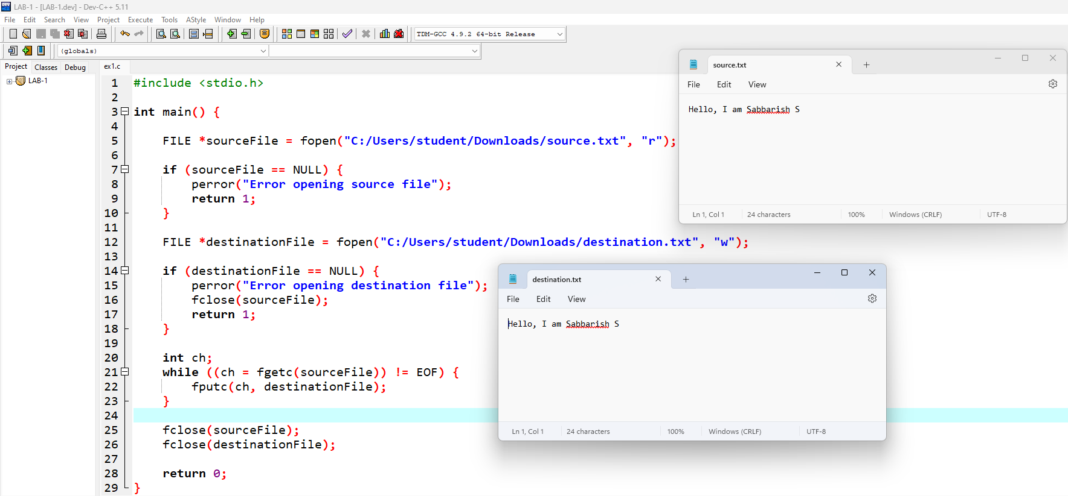

Count the Number of Lines in a File:

• Write a program that opens a file named "data.txt" and counts the number of lines in the file. Print the total number of lines.

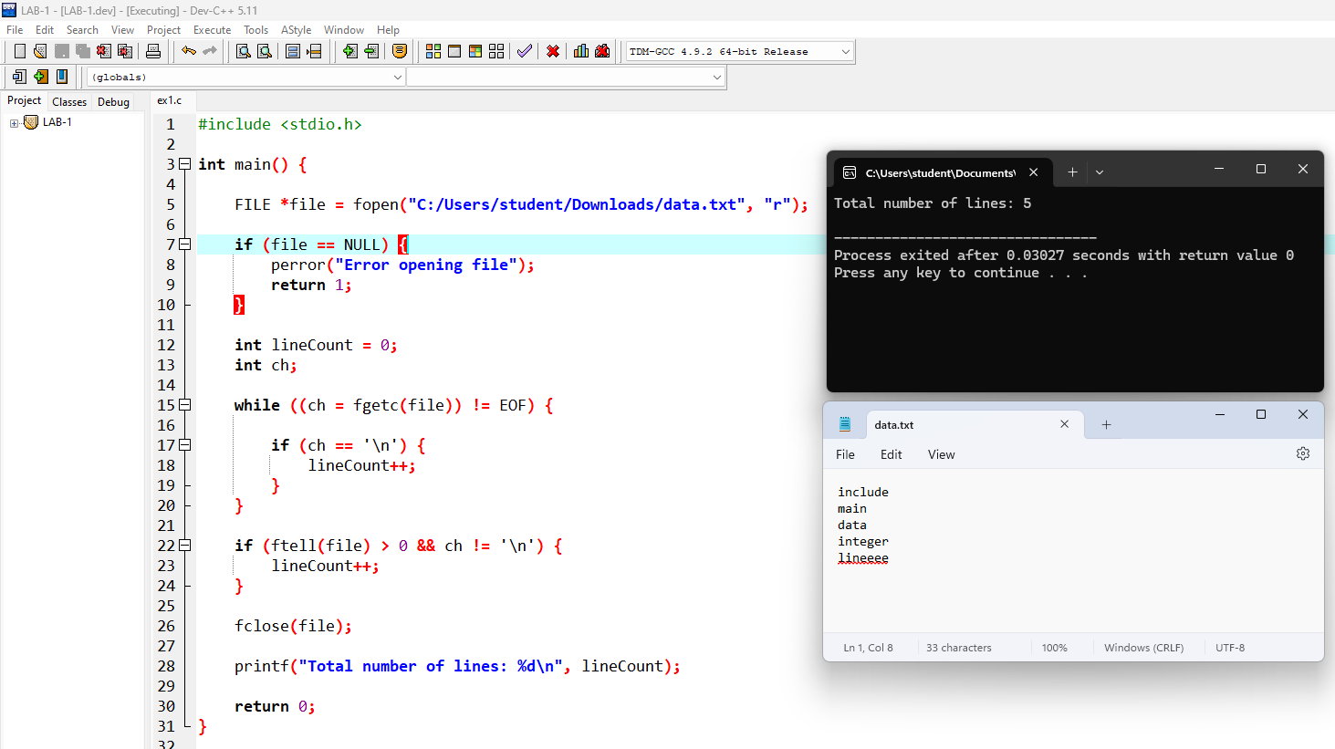

Count the Number of Words in a File:

• Write a program to count the number of words in a file named "text.txt". Assume that words are separated by spaces, tabs, or newlines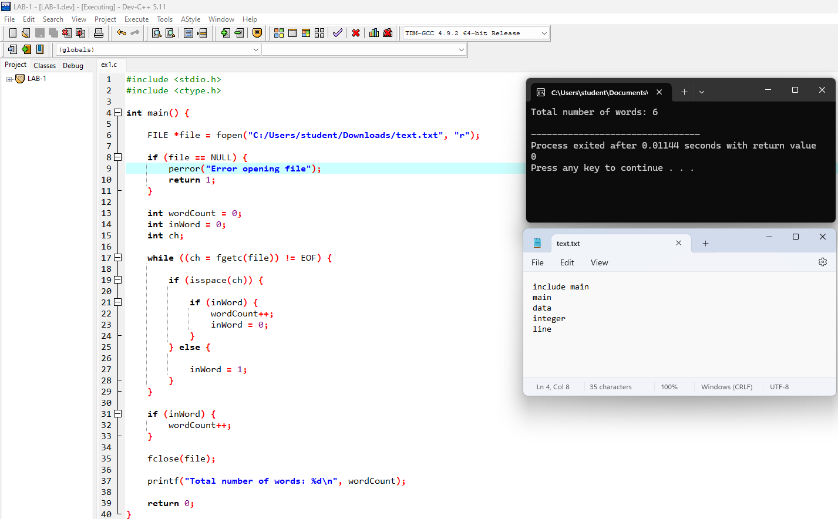

**Creation of Symbol table**

Write a C program that implements a symbol table with functions to create, insert, modify, search, and display symbols. The program reads symbols from a file named "input.txt", with each symbol assigned a starting address of 1000 and each symbol occupying 3 bytes.

Requirements:

• Read symbols from "input.txt".

• Assign addresses starting from 1000, with each symbol occupying 3 bytes.

• Store each symbol and its corresponding address in a symbol table.

• Print the symbol table in a formatted manner

